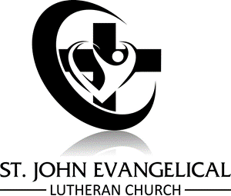
A message from the St. John Executive Board: The COVID-19 pandemic has affected all of our lives since March 2020 when churches were closed to prevent the spread of the virus. The St. John Lutheran Church Executive Committee, Council, and staff are committed to protecting the health and welfare of the members of our congregation and have prepared a reopening plan that outlines what church activities are allowed as we progress further into the COVID-19 pandemic. This was based on reviewing current government and ELCA publications, health authority publications, and interviews with local health providers. It is a complicated situation with no easy answers. Once the plan is approved, it will be made available to the congregation.

No matter what phase of the plan we are operating under, we ask that all members follow the recommendations to help mitigate the spread of the virus, practicing social distancing, wearing masks, and proper hand hygiene (soap and water or 60%+ alcohol hand sanitizer). Be responsible. Do not attend or visit the church if you are feeling ill, have been exposed to someone with COVID-19, have a compromised immune system, or are at high risk of exposing others. The best way you can love your neighbor is to protect their health and yours. If at any point in time a parishioner becomes ill with COVID-19 and has been in attendance at church, a small group, or worship service, the parishioner is highly encouraged to contact Pastor Leeper or church office staff immediately in order that the church may assist with contact tracing and initiate appropriate disease mitigation processes.

The Executive Committee and Church Council asks that the members of St. John please remain patient throughout the reopening process, keeping in mind this may take some time to work through. This is new territory for all of us and we are endeavoring to make the best decisions we can. As the people of St. John, we must be prepared to take a few steps forwards and possibly many steps backwards at any point in time. The Church Council is committed to regularly reviewing the reopening process and making scientific, fact-based decisions in conjunction with thorough moral deliberation that benefits the well-being of all the people of St. John and the greater Charles City community.

